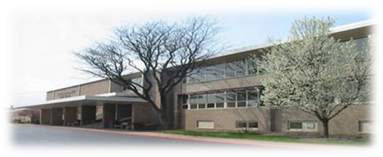
PURPOSE: To provide a scholarship to a deserving Susquehanna Township High School graduating senior accepted as an undergraduate at an accredited post-secondary institution such as a college/university or vocational/technical institute, commercial art school, school of nursing, etc.
AWARD COMPONENTS: A $750 scholarship awarded directly to a graduating senior(s) selected by the Susquehanna Township High School Alumni Association Scholarship Committee.
CRITERIA:
- Applicant must be a graduating high school senior in the year of the award.

- Applicant must be accepted at a post-secondary institution (college/university or vocational/technical institute, commercial art school, school of nursing, etc.) as a freshman in the coming academic year.

- Applicant must demonstrate strong leadership qualities and have been involved in sustained community and personal activities a minimum of one year.

APPLICATION PROCESS:
- Submit a completed TYPEWRITTEN application form (incomplete applications will not be processed). A Resume may be attached in lieu of or to supplement the application.

- Submit, at a minimum, one letter of recommendation from the student’s high school teacher, administrator or current/former employer.

- Attend an Alumni Association Scholarship Committee face-to-face interview.

Application Deadline is March 31, 2021.
Applications received after this date will not be considered.

An application is also available on the Alumni web page under Scholarships and on the high school
Guidance Center webpage.

Submit application packet to:
Susquehanna Township High School Guidance Office
Attention Ms. Nadine Plott, Guidance Secretary
nplott@hannasd.org, (717) 657-5117 x 40117

SCHOLARSHIP FOR HIGH SCHOOL SENIORS

STUDENT APPLICATION
Please read this form carefully and answer each question completely. Your application will not be processed if all of the questions are not answered in full. Mark N/A for items not applicable. Your application must be typewritten.

PERSONAL DATA
Full Name ________________________________________________________________________
Email Address _________________________________ Telephone No. _______________________
Street Address _____________________________________________________________________
City/State/Zip Code _________________________________________________________________
Full Name and Address of Parent(s) or Guardian(s):
______________________________________ ______________________________________
______________________________________ _____________________________________
______________________________________ _____________________________________

EDUCATIONAL INFORMATION

Where do you plan to attend college?
College or university address ___________________________________________________________
Have you currently applied for admission? _____________ Been accepted? __________________
Proposed major _____________________________________________________________________
BIOGRAPHICAL (BACKGROUND) SUMMARY

ACTIVITIES/ORGANIZATIONS
Please list activities/organizations in school and within the community. Indicate offices held and accomplishments while in office.

1.

2.

3.

4.

5.

HONORS/AWARDS
Please list.
1.

2.

3.

4.

5.

WORK EXPERIENCE
Include both paid and volunteer work experience and job duties performed.
1.

2.

3.

4.

5.

SIGNATURES (REQUIRED)

__________________________________________________________ __________________
Signature of Applicant Date

__________________________________________________________ __________________
Signature of Parent or Guardian Date

__________________________________________________________ __________________
Signature of School Guidance Counselor Date

